App in a Day

Hands-on Lab Step-by-Step

December 2019

Contents

Importing Module 3 Completed 1

Task 1: Create a new environment 1

Task 2: Import the solution 2

Task 3: Import the application 5

Task 4: Test Device Procurement App 8

# Importing Module 3 Completed

Follow the steps below, if you did not complete Modules 1, 2 or 3 and would like to skip to Module 4

## Task 1: Create a new environment

1. Open a new browser tab, navigate to <https://admin.powerapps.com> select **Environments** and click **New Environment**.

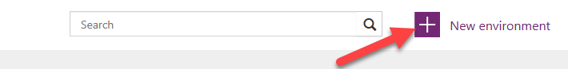

1. Provide an **Environment Name**, select **Region**, select **Environment Type**, and click **Create Environment**.

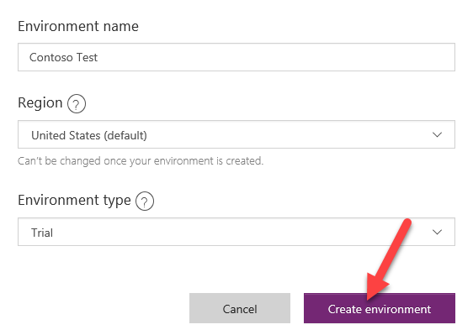

1. Click **Create database**.

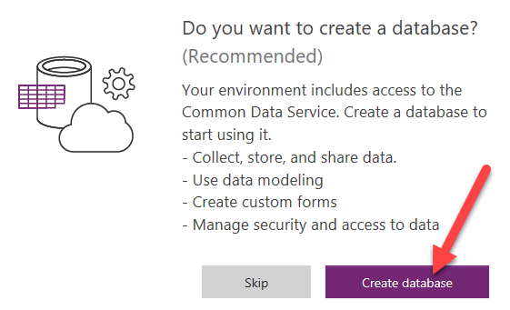

1. Select **Currency** and **Language**, and then click **Create database**.

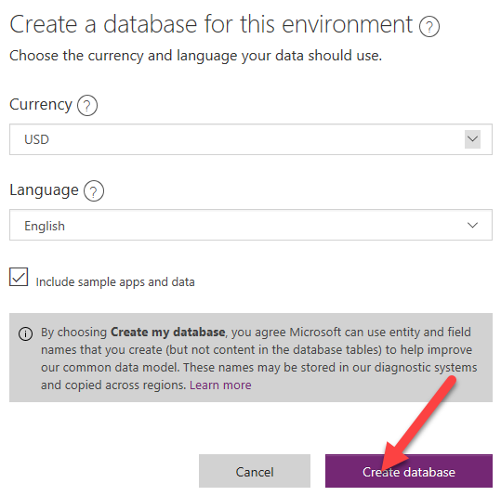

Wait for the database to be created

## Task 2: Import the solution

In this task, you will import the completed module 3 solution.

1. Open a new browser tab, navigate to <https://make.powerapps.com>
2. Make sure to select the correct environment.



1. Select **Solutions.**

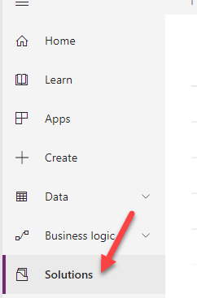

1. Click **Import**.

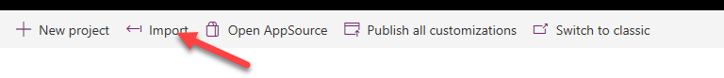

1. Click **Browse**.

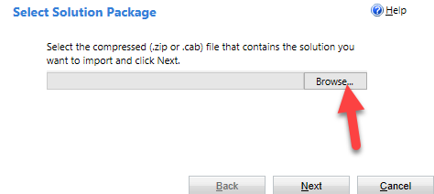

1. Select the Module 3 Completed Solution zip file located in Module 3 Completed folder and click **Open**.

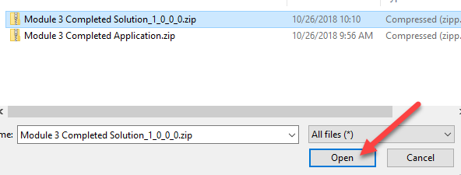

1. Click **Next**.

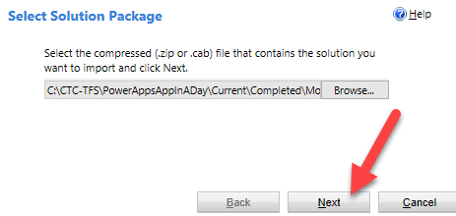

1. Click **Next**.

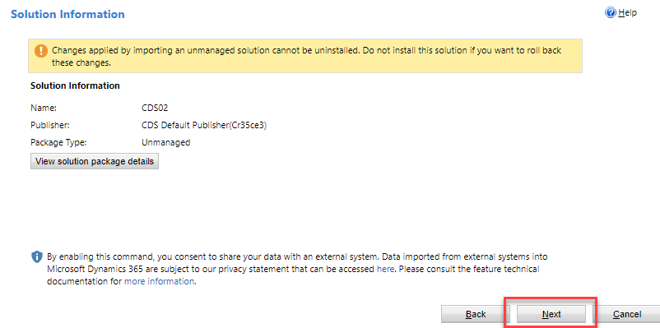

1. Click **Import**.

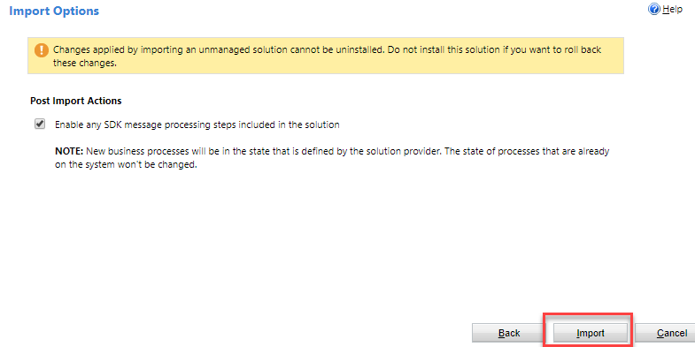

1. Wait for the solution import to complete and click Close.

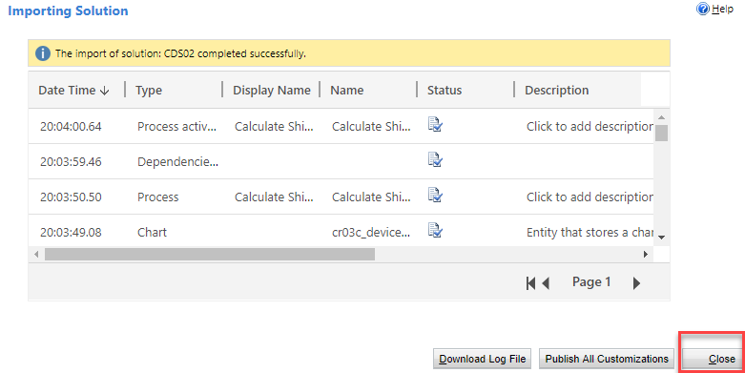

1. Click **Publish All Customizations** and wait for the publishing to complete.

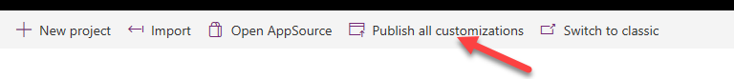

## Task 3: Import the application

In this task, you will import the completed module 3 application.

1. Select **Apps** and click **Import Canvas App**.

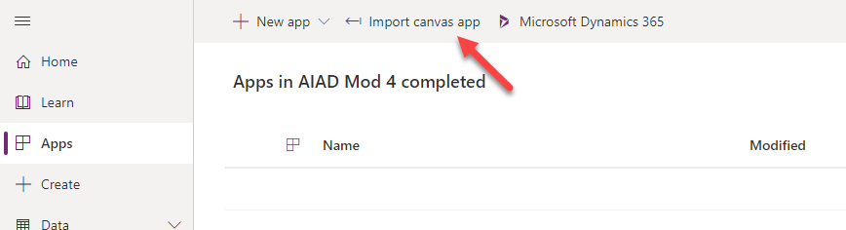

1. Click **Upload**.

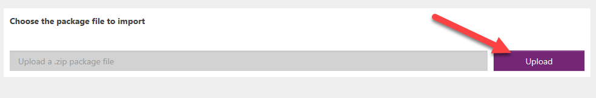

1. Select the Module 3 Completed Application zip file located in Module 3 completed folder and click **Open**.

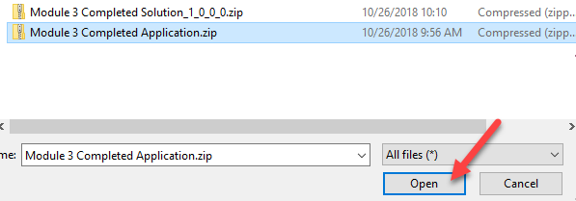

1. Click **Import**.

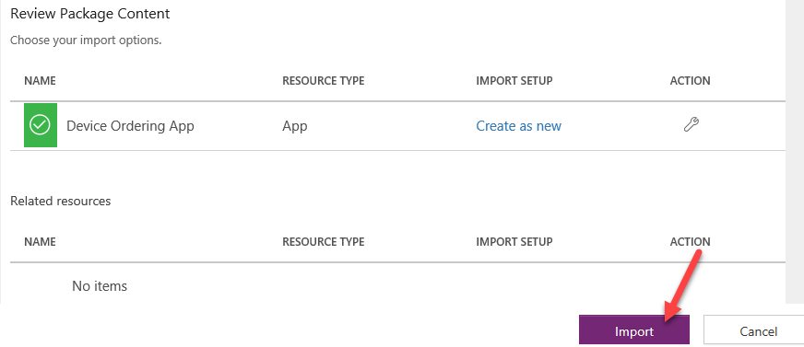

Wait for the application import to complete.

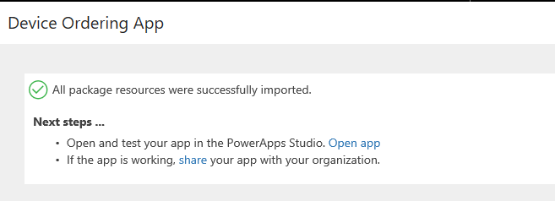

1. Select Apps, click on the … button of the application you imported and click **Play**.

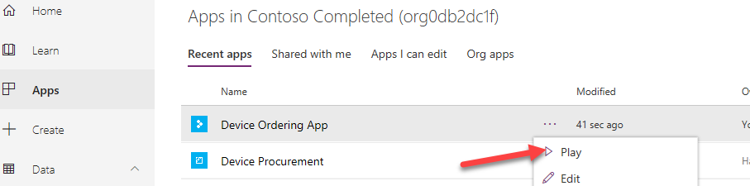

1. Click **Allow**.

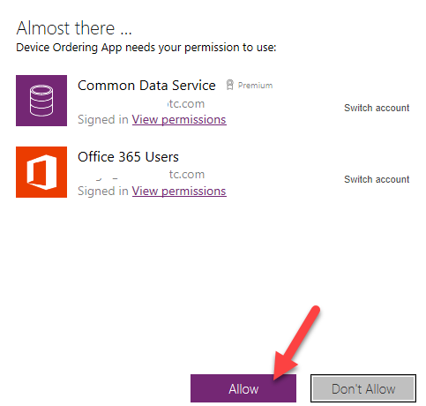

1. Select few devices and click **Compare**.

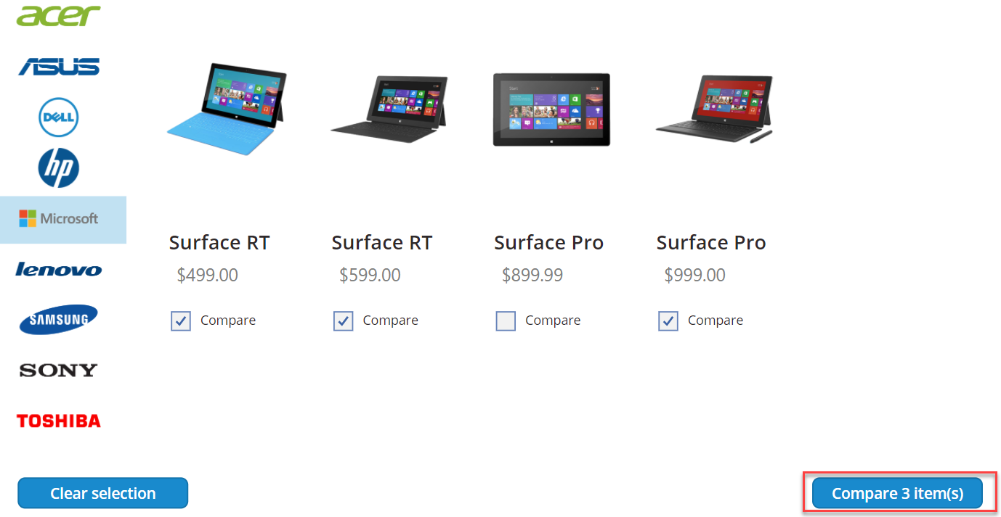

1. Select one of the devices and click **Submit**.

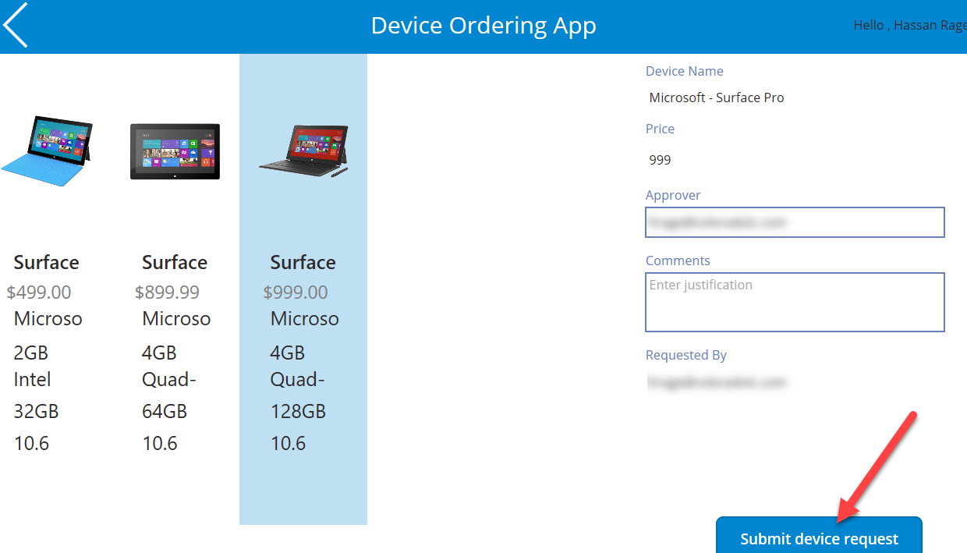

1. Click **OK**.

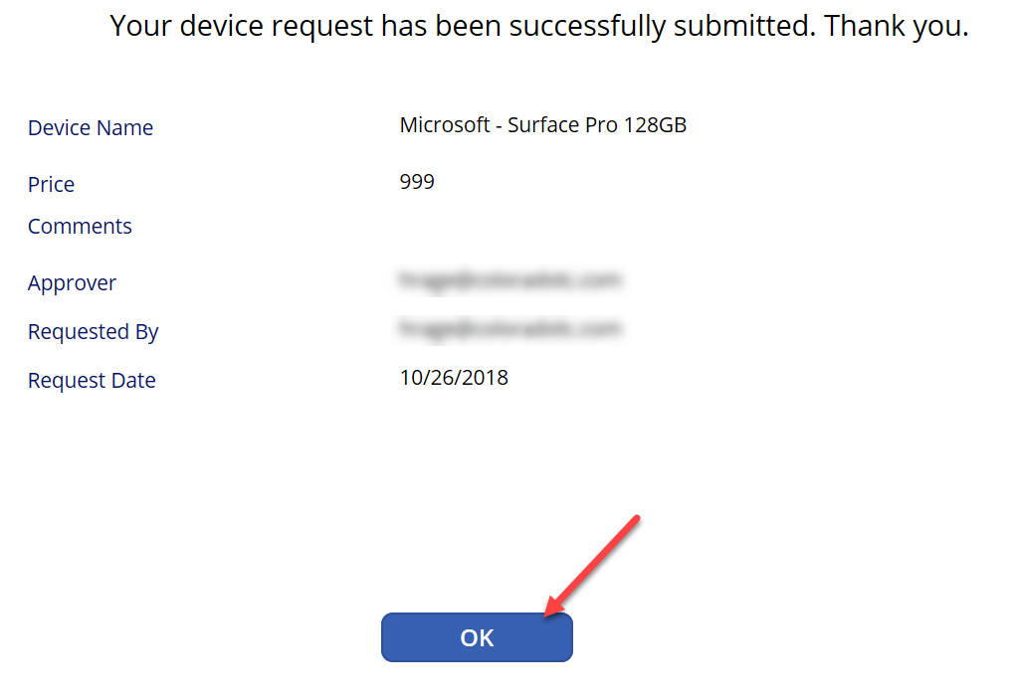

1. Close the application.

## Task 4: Test Device Procurement App

1. Select App and start the Device Procurement application.

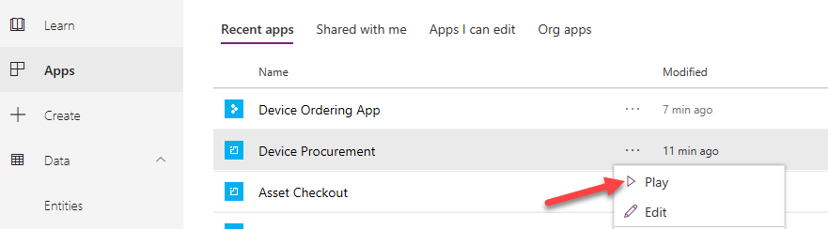

1. You should see the device you ordered on the list.

